“DC Management”

Submitted to

International Institute of Professional Studies
Devi Ahilya Vishvavidyalaya, Indore(M.P)

By
Pulkit Vaishnav (IT-2K11-25)

For the partial fulfillment of the requirement for the Master of Technology(IT) (5 ^{1/2} Years) VI Semester
Session Jan-May 2014

Under the guidance of
Ms. Manju Suchdeo

DECLARATION

I hereby declare that the project entitled “DC Management” which is submitted by me for the partial fulfillment of the requirement for the Master of Technology (5 ^{½} Years) VI Semester to International Institute of Professional Studies, Devi Ahilya Vishwavidyalaya, Indore(M.P), comprises my own work and due acknowledgement has been made in text to all other material used.

Signature of Student:
Date:
Place: Indore

International Institute of Professional Studies

Devi Ahilya Vishwavidyalaya, Indore (M.P)

CERTIFICATE FROM GUIDE

It is to certify that project on “DC Management ”, submitted by Pulkit Vaishnav to the International Institute of Professional Studies, DAVV, Indore(M.P) has been completed under my supervision and the work is carried out and presented in a manner required for its acceptance in partial fulfillment for VI semester of Master of Technology (5 ½ years).

Project Guide Signature:
Name: Ms. Manju Suchdeo
Date:

International Institute of Professional Studies

Devi Ahilya Vishwavidyalaya, Indore (M.P)

CERTIFICATE

It is to certify that we have examined the project on “DC Mangement”, submitted by Pulkit Vaishnav to the International Institute of Professional Studies, DAVV, Indore(M.P) and hereby accord our approval of it as a study carried out and presented in a manner required for its acceptance in partial fulfillment for VI Semester of Master of Technology (5 ½ years).

Internal Examiner External Examiner
Signature: Signature:
Name : Name :
Date : Date :

ACKNOWLEDGEMENT

Every project is the result of the toil of the craftsmen and sacrifice and forbearance of those they were forced to neglect. Rubies are beneath their worth.
I acknowledge here my debt to those who have contributed significantly to this project. I would like to express my deep sense of gratitude to my project guide Ms. Yasmin Shaikh who has been a source of inspiration for me all through the project and he not only provided me the technical guidance but also his moral support and encouragement. He guided and helped me through out the entire course of time. And whenever there was any ambiguity of idea or thought, he patiently dealt in depth and provided clarification and direction to proceed. I am truly grateful for his wisdom and I thank him with all my heart.
A special mention needs to be made for Dr. Anand Saphre, Director IIPS, DAVV , former director Dr. B.K. Tripathi and Ms. Kirti Mathur Head, Computer Programme, who helped very willingly as often as I wanted and cooperated with interest.
I also thank Mr. Shaligram Prajat for providing me technical guidance and support whenever required.
My colleagues and classmates also deserve a mention for their constant review, praise and critical appraisal.
Before ending I would like to thank my Parents, and friends who have always stood by me whenever I was in need of them. I sincerely regret any inadvertent omissions.

With my heartiest thanks to all,

Pulkit Vaishnav

Table of Content

1. Introduction………………………………………………………………………………..8
1.1 Problem Description……………………………………………………………..9
1.2 Project Aim………………………………………………………………………9
1.3 Project Description…………………………………………………………….....9
1.4 Tools…………………………………………………………………………….....9
2. Feasibility Study………………………………………………………………………….10
2.1 Existing System and Limitation………………………………………………..11
2.2 Proposed System with Objective……………………………………………….11
2.3 Feasibility Study………………………………………………………………...11
2.3.1 Economic Feasibility Study……………………………………………..11
2.3.2 Technical Feasibility Study……………………………………………..12
2.3.3 Behavioral Feasibility…………………………………………………...12
3. System Analysis…………………………………………………………………………..13
3.1 System Analysis…………………………………………………………………15
3.2 Preliminary Investigation………………………………………………………15
3.3 Requirement Specification……………………………………………………..15
3.3.1 Hardware………………………………………………………………...15
3.3.2 Software Requirement…………………………………………………...15
4. System Design…………………………………………………………………………….16
4.1 Entities Definition……………………………………………………………….17
4.2 E-R Diagram……………………………………………………………………19
4.3 Use Case Diagram………………………………………………………………20
4.4 Use Case Description……………………………………………………………21
4.5 Data Flow Diagram……………………………………………………………..22
4.6 User Interface…………………………………………………………………...23

5. System Testing……………………………………………………………………………28
5.1 Preparation of Test Data……………………………………………………….29
5.2 Black-Box Testing……………………………………………………………....29
5.3 White- Box Testing……………………………………………………………...29
5.4 Unit Testing………………………………………………………………….…..30
5.5 Integration Testing……………………………………………………………...30
6. Conclusion………………………………………………………………………………...31
6.1 Findings………………………………………………………………………….32
6.2 Limitations………………………………………………………………………32
6.3 Scope for Future Prospects……………………………………………………..32
7. Bibliography& References………………………………………………………………33
7.1 Reference Books………………………………………………………………...33
7.2 Other Documentation and Resources………………………………………….33

INTRODUCTION

1. Introduction
1.1 Problem Description
The purpose of this project is for institutional basis. The project is developed to give the detailed description of the requirements of the new IIPS DC site. There is already a existing website present of DC of IIPS but have some limitations. Some of which are:
- Not a mobile responsive site
- Only 100MB of storage available freely
- Limited page design option as no open use of CSS or JavaScript permitted
- Lack of security as not available separate login for each authorized person
1.2 Project Aim
The aim of this project is to integrate all the information related to Development Center at one place and to automate all the work of Development Center which are currently running manually
1.3 Project Description
The newly designed site provides well managed user friendly environment in which it will become a mobile responsive site and the content delivery is flexible to accommodate all screen sizes so that it can operate on mobile too.
The site is developed in such a way that every DC member will maintain his/her daily dairy and also manages his/her information regarding his/her current project and past projects. The whole monitoring is observed under DC-in charge.
Each and every member have his own ID password to login in to the DC site and only the authorized person can make change in to the database only and there is only limited access provided to the visitors .
1.4 Tools
Following are the tools used in the System :
Application architecture – PHP, HTML, CSS, JavaScript and jQuery
Web server – LAMP or WAMP Server (any with PHP support)
Database platform –Phpmyadmin

FEASIBILITY STUDY

2.1 Existing System and Limitation
There is already an existing website present of DC of IIPS but have some limitations. Some of which are:
- Not a mobile responsive site
- Only 100MB of storage available freely
- Limited page design option as no open use of CSS or JavaScript permitted
- Lack of security as not available separate login for each authorized person
.
2.2 Proposed System with Objective
Following are the various objectives that the application would be aiming to fulfill:
  - To provide well managed user friendly environment in which it will become a mobile responsive site.
  - To provide single sign on facility through Google for the security purpose for every individual.
  - To facilitate the admin to have control on DC member by his/her daily log
  - To take care of management of current and past projects running in DC
  - To facilitate every DC member to maintain his/her daily log and projects
  - To provide a entrance procedure for newcomers in Development Center.

2.3 Feasibilty Study
Feasibility study examines how beneficial is the project economically, technically and non- technically. This DC Management is a truly feasible project and satisfies all the three conditions described below:
2.3.1 Economic Feasibility:
The economic analysis of the project counts for the cost effectiveness of the project. Economic feasibility requires one to make the cost benefit analysis. At this level the project may be called a demo project at desktop level. Therefore, it is not possible to measure the benefits accruing and cost of installation. Such study can be made only the project advances to a higher level. Economic feasibility considers the following:
1. The cost to conduct a full system investigation.
2. The cost of hardware and software for the system.
3. The benefit in the form of reduced cost or fewer costly errors.
4. Cost if nothing changes (i.e. the proposed system is not developed).
But this project can be regarded as economically feasible because the courier office possesses the computer with them, so there is no need of bearing any cost on the resources needed for the development of the system. The only cost involved in the project is the installation cost. The only resource required for proper and successful installation is a computer system meeting software and hardware requirements of the system. These costs are quite minimal and easily available with the organization. In addition, there are no start-up costs for any equipment installations, recruitment of new personnel, and cost of disruption to the rest of the system
2.3.2 Technical Feasibility:
In this project, we can say that this project will be technical feasible. This is successfully satisfying the users of the basis requirement. The tools and application software are used in this project are very popular and easily available across the world. My project is a demo project completely applicable the ground level of department desktop computer this can easily enhanced by a team of experts on the basis of my project and its data collection report.
For the setup of the project minimum software and hardware requirements are given above. The criteria for technical feasibility of DC Management are:
Easy to use
The users were assumed to be normal ordinary people having knowledge of simple computer operation, so ease of use is a very essential factor if we want to get the job actually done quickly.
Security
As the DC member s personal details are also present in the system, we provide login facility so that only authorized person can access.
Reliability
In this project the technical feasibility is considered up to a great extend. The website is build using open source technology.
2.3.3 Behavioral Feasibility
Behavioral feasibility of DC Management is the measure that how effectively the system is used. It is one of the major factors of feasibility analysis. The new and the proposed system- “DC Management” is
- Easy to operate,
- Effective in its work.
- In all the areas of application the expanded results are better than the earlier.
- Individual performance is not expected to deteriorate after implementation.
- Retrieval of information is easy, accurate and fast.
Thus behavioral feasibility is very important factor to be considered for effective working of system. The systems analyst must still consider the behavioral feasibility of the requested DC Management. It is dependent on the human resources available for the users who wish to work with websites by downloading them along with their associated links and images.

ANALYSIS

3. System Analysis:
3.1 System Analysis
- Designing a mechanism which can act as a platform for user to efficiently retrieve the Development Center information.
- Designing a user friendly graphical user interface for entrance of newcomers.
- To develop a print out of form so that newcomer can fill up the form and take it to the admin for approval.
- DC member can manage their details efficiently.
- User has the security with the data he/she enter.

3.2 Preliminary Investigation
This website is designed according to the requirement of DC. There is an old site in which there are some problems exist. We design a web application to overcome those problems. In previous site, the data of each member is visible to all other and some project detail is also may be modified by someone. A login facility is designed so that each member can access their information individually. If DC Management come into existence it will simply the system.
3.3 Requirement Specification
The requirement specification of the DC Management is as follows:

3.3.1 Hardware Interface:
- This is a web based application so it require a device which supports internet.

3.3.2 Software Interface:

- It requires a advanced browser like Mozilla 4.0 version and Chrome.

DESIGN

4 System Design
1. DC Member table
FIELD TYPE DEFAULT KEY

member_id varchar(15) NOT NULL Primary
first_name varchar(20) NOT NULL
last_name varchar(20) NOT NULL
date_of_birth date NOT NULL
gender varchar(2) NOT NULL
blood_group varchar(2) NOT NULL
local_address varchar(40) NOT NULL
parmanent_address varchar(40) NOT NULL
father_name varchar(30) NOT NULL
mother_name varchar(30) NOT NULL
guardian_name varchar(30) NOT NULL
course_name varchar(10) NOT NULL
github_id varchar(20) NOT NULL
linkedin_id varchar(30) NOT NULL
sem_of_joining integer(2) NOT NULL

2. Entrance table
FIELD TYPE DEFAULT KEY
serialno int(5) NOT NULL Primary
date_of_joining date NOT NULL
first_name varchar(20) NOT NULL
middle_name varchar(20) NOT NULL
last_name varchar(20) NOT NULL
birthday date NOT NULL
gender varchar(10) NOT NULL
bloodgroup varchar(10) NOT NULL
area_of_interest varchar(100) NOT NULL
basic_skills varchar(100) NOT NULL
current_address varchar(100) NOT NULL
permanent_address varchar(100) NOT NULL
country_code varchar(10) NOT NULL
std_code varchar(10) NOT NULL
mobile_no varchar(11) NOT NULL
student_email varchar(30) NOT NULL
github_id varchar(30) NOT NULL
fathers_name varchar(30) NOT NULL
fathers_contact varchar(11) NOT NULL
fathers_email varchar(30) NOT NULL
guardian_name varchar(30) NOT NULL
guardian_contact varchar(11) NOT NULL
school_name varchar(50) NOT NULL
percentage_10th varchar(10) NOT NULL
percentage_12th varchar(11) NOT NULL
course varchar(11) NOT NULL
semester varchar(11) NOT NULL
cgpa varchar(11) NOT NULL
online_courses varchar(100) NOT NULL
project_name varchar(11) NOT NULL
project_type varchar(20) NOT NULL
project_duration datetime NOT NULL
project_desc varchar(50) NOT NULL
reference_catg varchar(30) NOT NULL
reference varchar(30) NOT NULL
why_choose varchar(50) NOT NULL

3. Daily Log
FIELD TYPE DEFAULT KEY
Member_id varchar(15) NOT NULL primary,foreign
date date NOT NULL
log varchar(200) NOT NULL
link varchar(100) NOT NULL

4. Projects
FIELD TYPE DEFAULT KEY
project_id varchar(10) NOT NULL primary
project_name varchar(20) NOT NULL
project_type varchar(20) NOT NULL
project_leader varchar(30) NOT NULL
team_id varchar(10) NOT NULL
dc_page_link varchar(30) NOT NULL
github_page_link varchar(30) NOT NULL

4.2 E-R Diagram

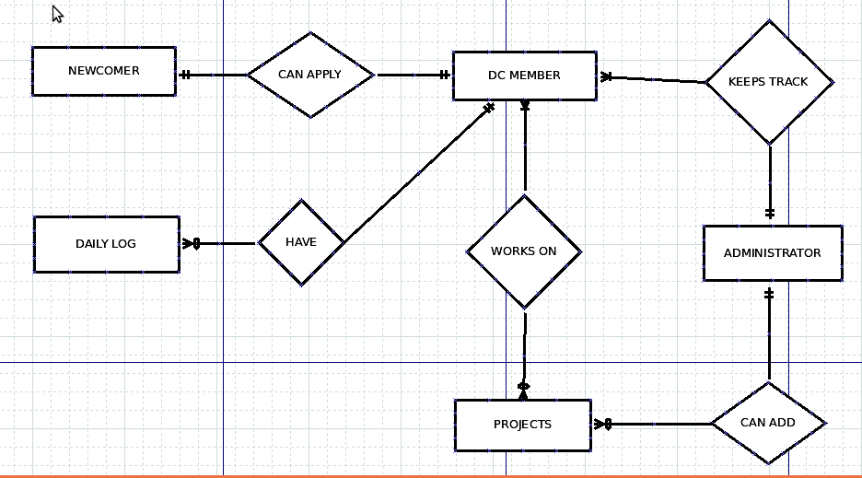
4.2 Use Case Diagram
4.2.1 Use Case: Visitors
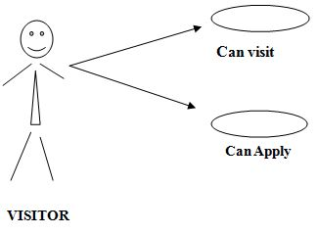

4.2.2 Use Case: DC member
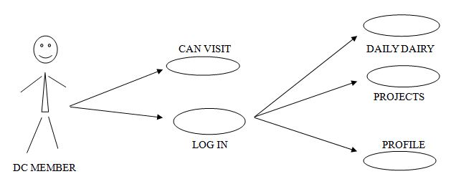

4.2.3 Use Case: Admin

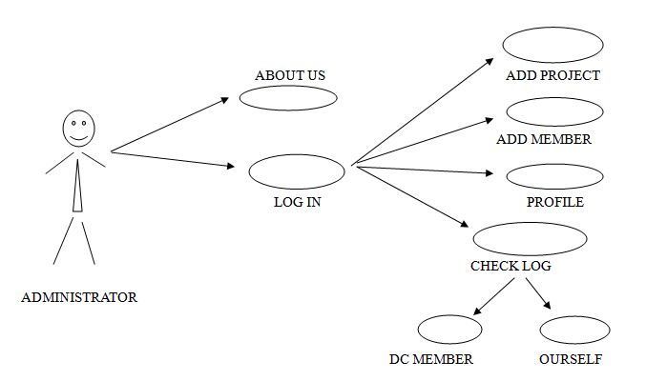

4.3 Use Case Description
1. Login: DC member has the login option through which he/she can enter into the system.
2. Visit: Visit means particular can visit the whole site.
3. Daily Dairy: Daily log of the individual.
4. Profile: Profile containing the individual’s information.
5. Projects: it is related with the details of current and past projects.
6. Apply: Visitor can apply for DC membership.

  - Data Flow Diagram

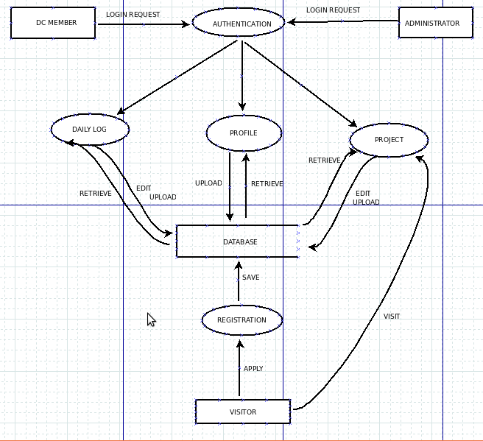

4.6 User Interface

Homepage:

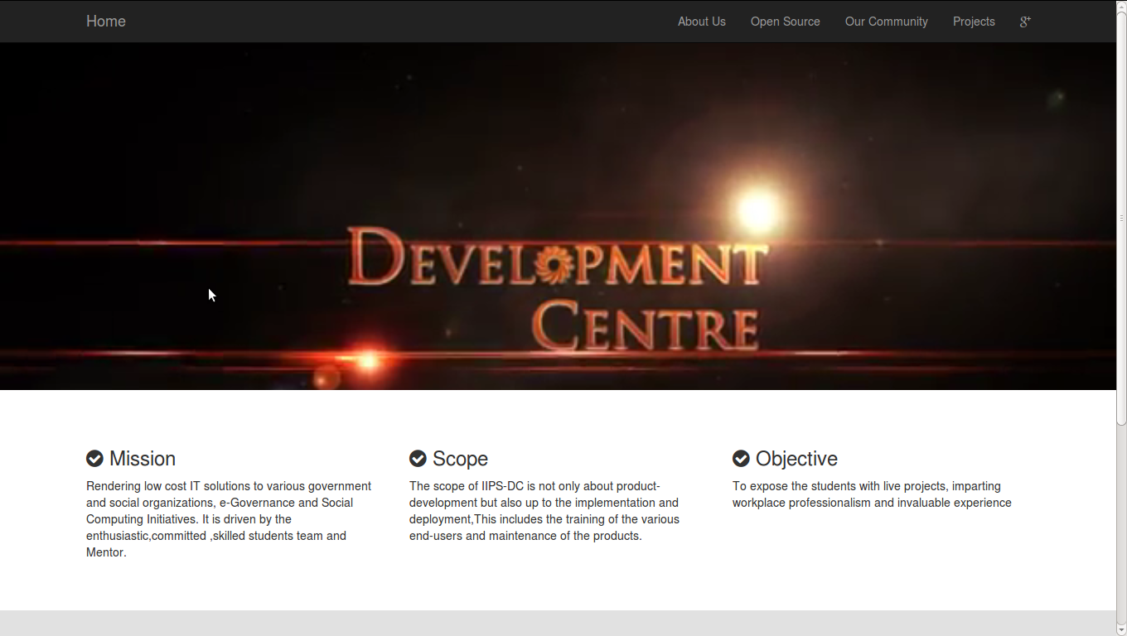
Description about opensource:

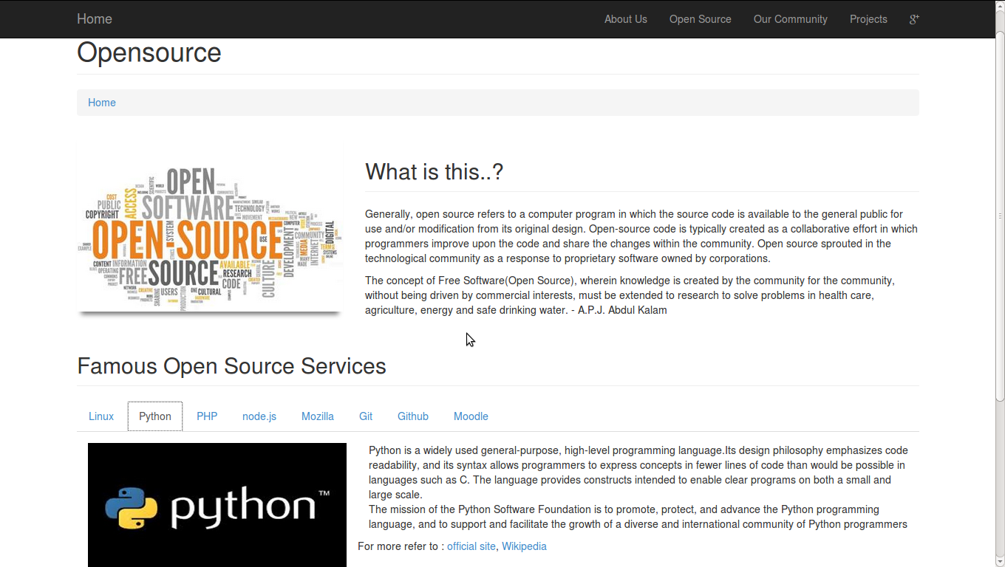
Projects:

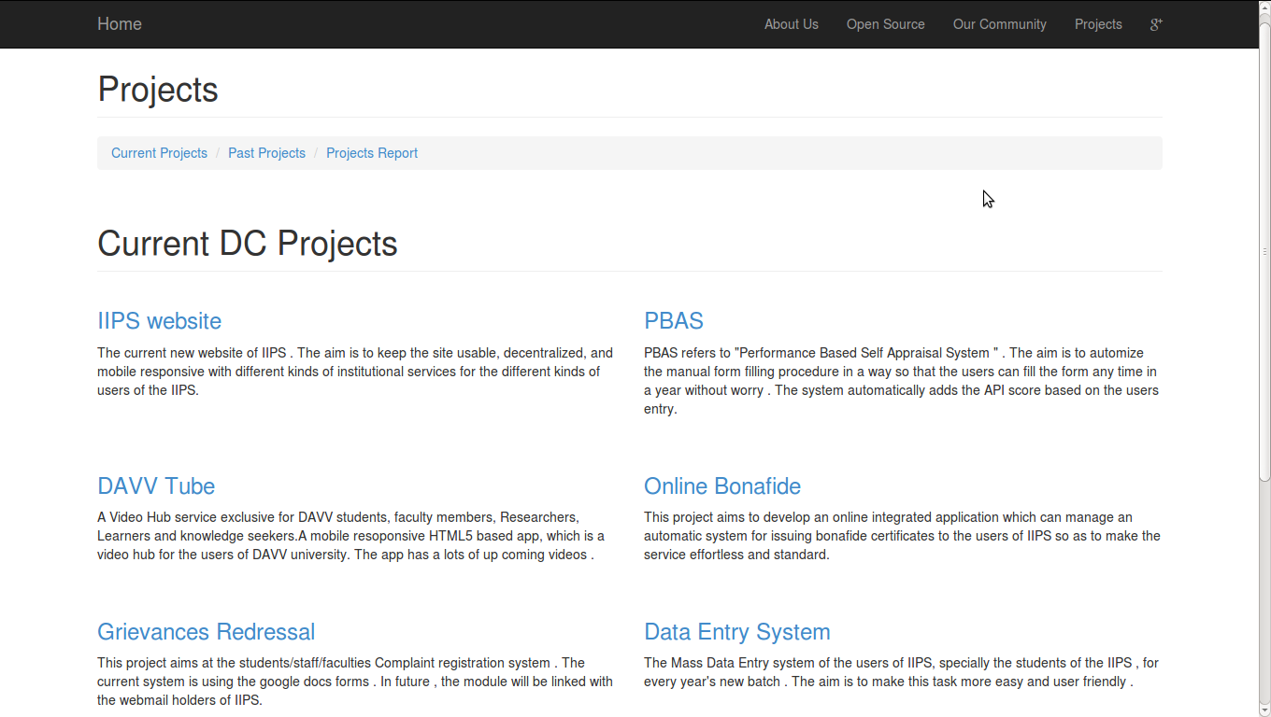

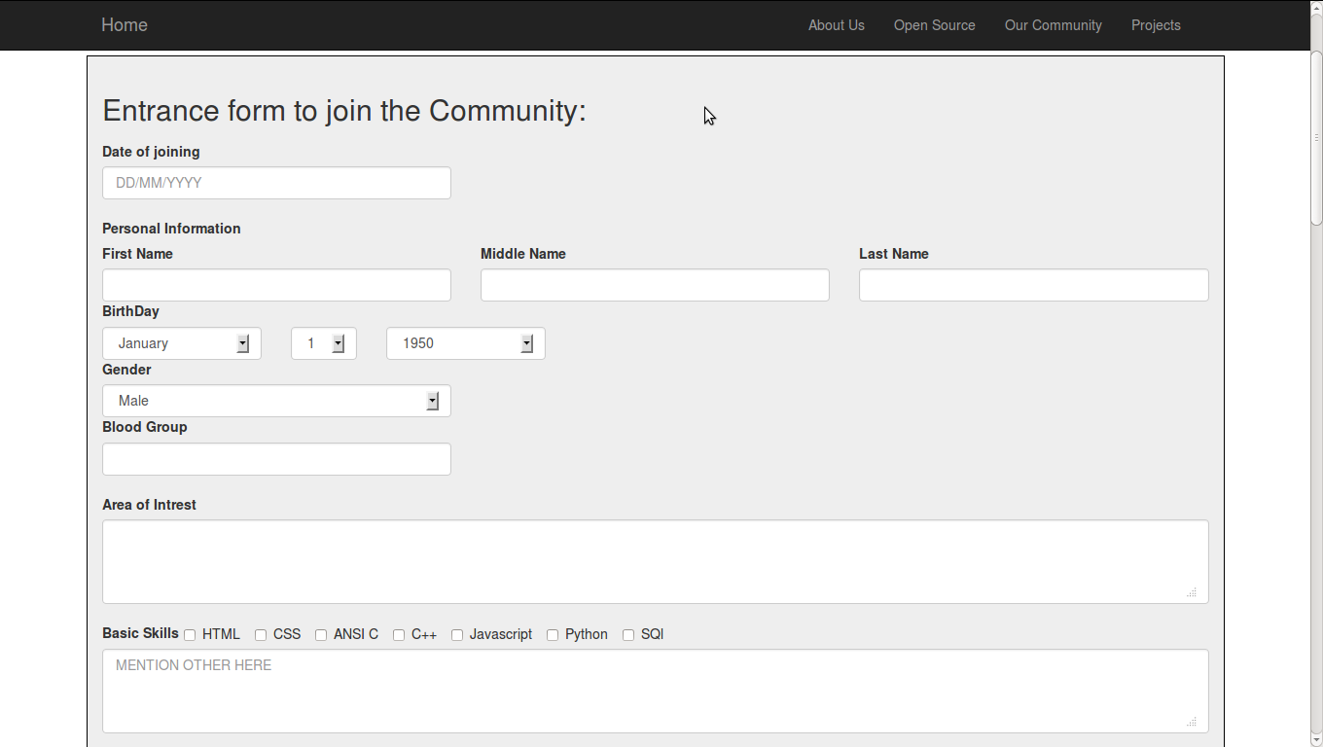
Entrance Form for Newcomers:

Our Community:

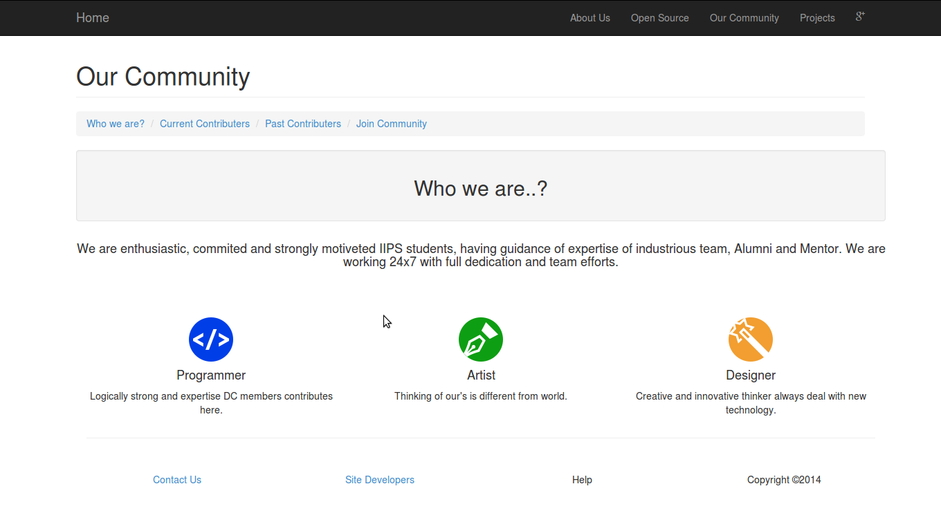

Sign in with Google for DC member and Admin:
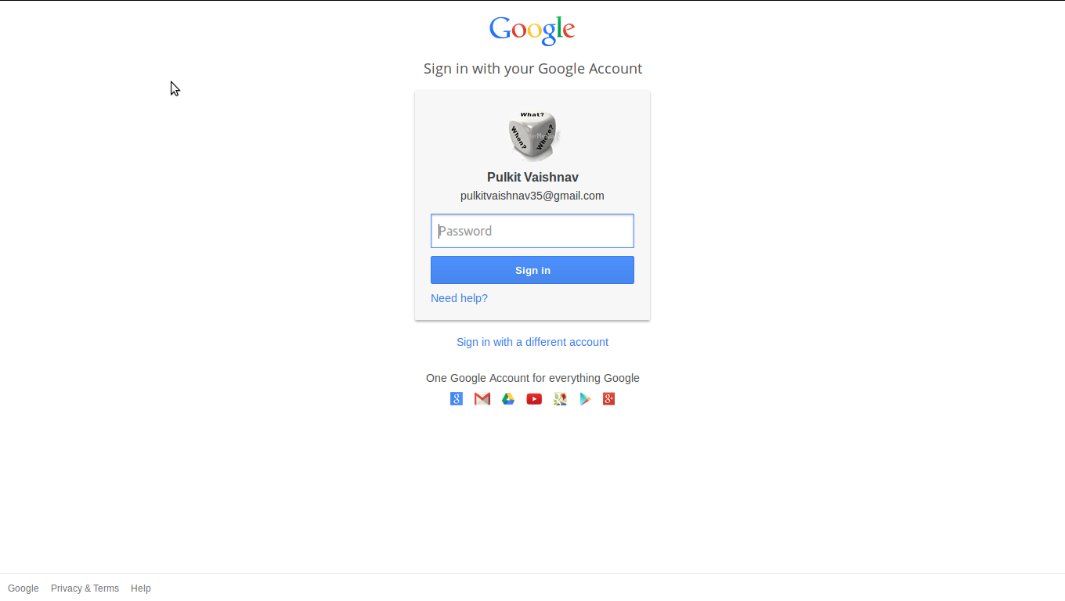
DC member Dashboard :
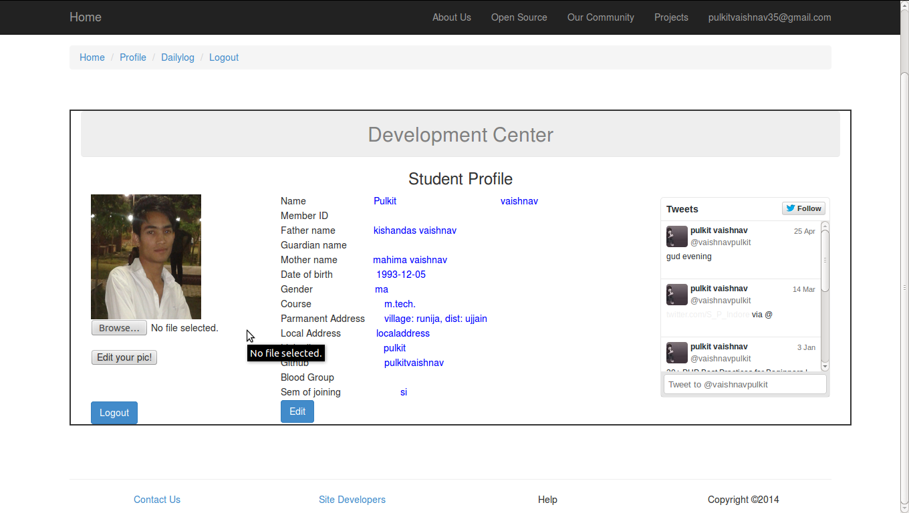
Daily Log Page of DC member:
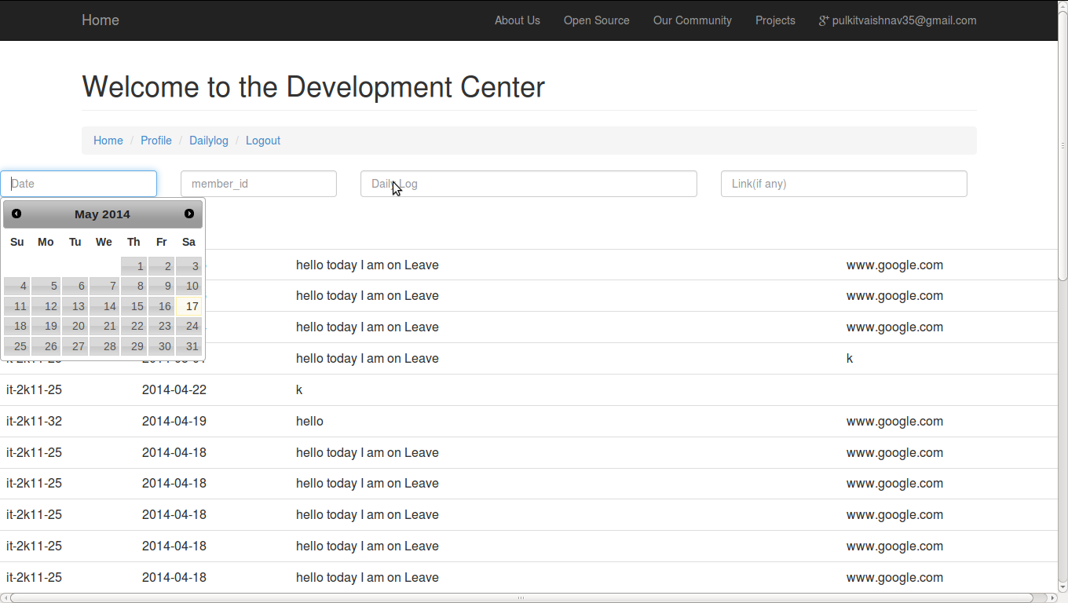

Admin page to monitor Daily Log:

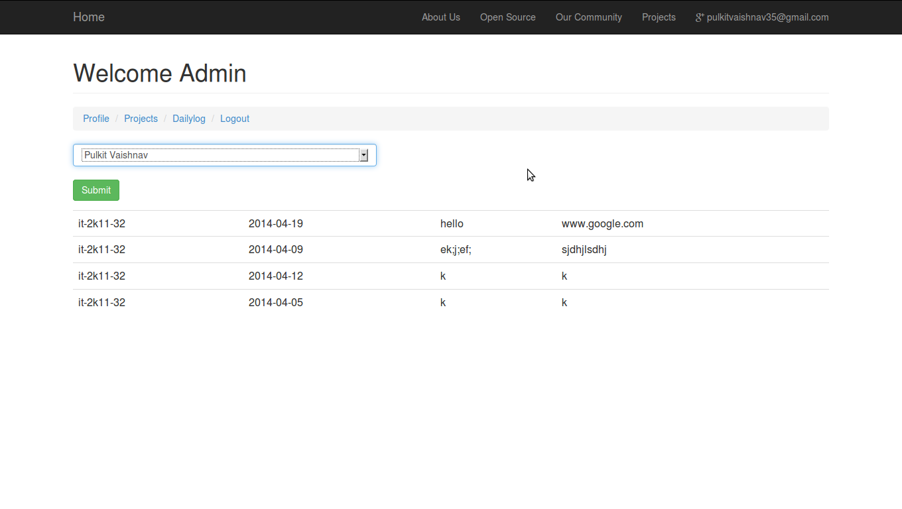
Admin page to monitor Projects:

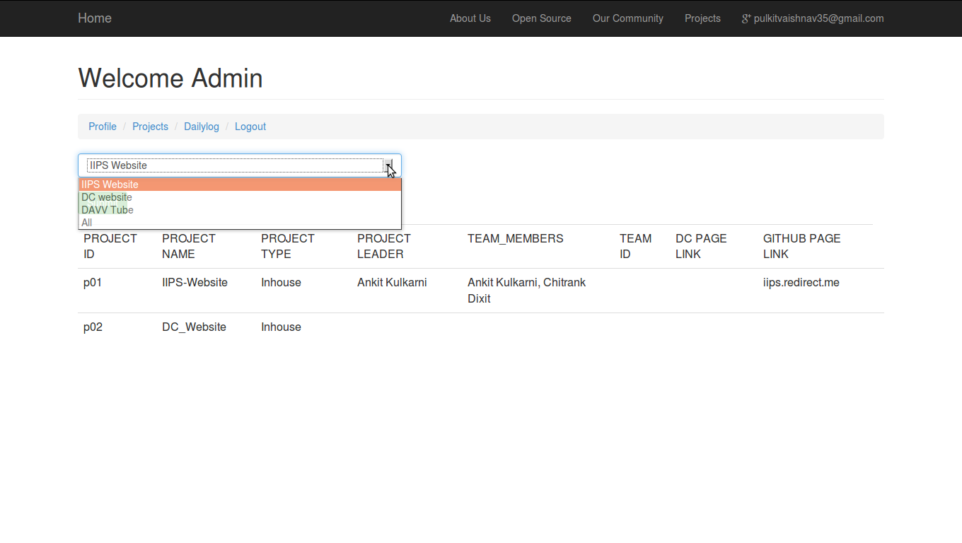

TESTING

5. System Testing
Testing should be done throughout the implementation process as we had done the testing while implementing the code. Even before an application is installed, it makes sense to verify that the basic platform is capable of achieving its design capabilities. System testing is a critical process. Testing is a process of executing a program with the explicit intention of finding errors that is, making the program fail. This help in finding the bottlenecks in the system .We have performed all the testing as required in the project in order to assure the proper functioning of it. Executing a program in a simulated environment performs testing. The feedback from testing phase generally produces changes in the software to deal with errors and failures that are uncovered.
5. 1 Black Box Testing:
In Black Box testing or functional testing test cases are decided. Test cases are decided on the basis of the requirements or the specifications of the program or module. We had performed black box testing in the project.
Black Box testing is done in the project to remove the errors
- Incorrect or missing function: So in the software there is no incorrect or missing function.
- Interface errors: There is no interface errors in the software.
- Behavioral or performance error. All the forms are working accordingly. And they are user friendly too.
- Errors in initiation & termination. There is no error in the termination of the program.

5.2 White Box Testing:
The White Box testing or Structural testing performs close operation of procedural details. They test the software logical path by having test cases exercising specific sets of conditions and loops. We had performed white box testing in my project as white box testing includes following things:
White Box testing is done in the project to remove the errors.

- All modules path have been exercised at least once. We have checked each and
every form in our project.
- Exercised on logical decisions. All the forms are working accordingly.
- Executed all loops at their boundaries and within their operational bounds.
- Exercised internal data structure to ensure their validity.

5.3 Unit Testing
Unit testing focuses on verification efforts of the smallest grid of software designing i.e. a software component or module is tested. This testing is done at the coding phase. This testing uses procedural design as guide to test major controls path and uncovers errors within the module boundary. In the unit testing we have tested each and every form for its proper functioning. After creating individual form we tested it by running it then debugging the respective form.

5.4 Integration Testing
Integration testing is done to tackle the problem of interface i.e. putting all the interfaces together. When the separate modules are put together and work in an integrated manner, this testing is performed. We have combined all the forms then tested for its integration i.e. after putting all the interfaces whether it is functioning properly or not. In this way we performed Integration testing. This testing is a Systematic technique. This testing is performed to check that data should not be lost across an interface. The objective is to take unit tested modules and build a program structure that has been dictated by design.

CONCLUSION

6. Conclusion
The Development center site provides a platform for all stack holders to work and integrate all content of Development Center at one place and the whole monitoring will be in under the administrator of the Development center.
The DC site gives a way to students to have a part of DC by applying through Entrance also DC members can now easily handle his/her daily log and hence they have proof of their performance and overall the Admin now easily evaluate the performance of every DC member.
The DC website have a special feature of login with Google which is completely for the purpose of security i.e now only the authorized person can have permission to access the confidential information and make changes in it.

6.1 Findings
The finding of this will result into:
- A user friendly interface to interact.
- Admin has ease of retrieving data and monitering.
- Newcomer can apply online.
- DC member can get data of daily log and Projects details.
- Personal data can’t be altered by any unauthorized person.

6.2 Limitations
Following are some of the limitations of DC Management over
- After entering daily log he will not able update to it.
- The major issue is that the single sign on requires a gmail account to login.
- Newcomer can’t able to register more than once in case of some errors.

6.3 Scope for Future Prospects
The future scope is that it will be a live website of IIPS Development center and in future there will be many enhancement can made
- Knowledge Center
- Blog
- Attendance system
- Leave system
- Infrastructure management system
- Training system
- Alumni correspondence
7. Bibliography& References
7.1 Reference Books
- System Analysis and Design – Elias M. Awad
- Modern Data Base Management System – Fred R. Mcfadden.

7.2 Other Documentation and Resources:
- http://php.net/docs.php
- http://www.phpmyadmin.net/
- http://www.phpmyadmin.net/
- http://jquery.com/

